Chapter 1
Introduction
This chapter will include the planning of the project that what steps will be carried out in order to create a desired network. It will define the problem and what steps were taken to solve it by taking different measures and also what is the significance of this project.
1.1 Company’s Profile/Overview
There is a company called IT solutions which has five branches which are in different countries. The company’s servers are in another country. They provide IT solutions such as data backup, data recovery, Web hosting, Cloud computing and Hardware/Software support across the countries.
  - Statement of the Problem
The company has five branches which are in different countries so they don’t have a system to be able to communicate with each other efficiently via some network. So they have to communicate with each other by using E-Mails.
The requirements of the company are:
- All the five branches should be connected with each other.
- Each branch should have an IP Phone to do voice communication.
- The devices should be automatically allotted the IP’s.
- There should be two servers one for Web and E-mail whereas another will be FTP server for files transfer.
- There should be an Access Control List to restrict he employees to certain tasks only.
1.3 Objectives of the Study
So as the company wants that all of its five branches which are in different countries be able to communicate with each other through some dedicated channel and access the information. The network has been created which will able them to communicate with each other over a channel without risking to use the normal internet all the time where there is a high chance of stealing of information. The network will allow the company to access its data servers through any of its branches in different countries and use IP phones to have voice communication. There is access control list also to restrict employees to certain tasks only and their own email server for communication. This network will help the company to communicate effectively with each other and save time to transfer information between different branches which are located in different countries
1.4 Scope and Limitations of the Study
The scope of this project is that it will allow the company to have a dedicated communication channel between all of its branches in different countries and be able to access information and keep in contact with each other with their own network and own email server as well as IP phones.
The limitations of this project is that it will not make use Virtual Private Network, firewalls or any backup communication channels which can be helpful when the primary communication channel is down.
1.5 Significance of the Study
The significance of this network is that it will allow the company to keep in contact with its branches across the countries over a dedicated communication channel. They don’t need to rely on normal internet all the time which is unsecure for them to transfer information. Moreover they can put restrictions on their employees as they like to. There is no need to have a separate server for each branch in each country. The servers will be in just one country and all branches can access them no matter in which country they are hence it will reduce the expenses for the company.
1.6 Definition of Terms
Following are the definition of terms which are used in this project
1.6 .1 Cisco Packet Tracer
The Cisco Packet Tracer is a network simulator which allows to create different networks and observe there behaviors. It helps to create a whole network on simulator and check it before actually physically implementing it anywhere.
1.6.2 Dynamic Host Configuration Protocol
The DHCP is a networking protocol which dynamically distributes the IP’s to different devices automatically with the help of a DHCP Server. So there is no need for anyone to manually issue the IP addresses to different devices.
1.6.3 Open Shortest Path First
The OSPF is a routing protocol. It purpose is to distribute IP routing information throughout a single Autonomous System in a network. In OSPF routers share topology information with their neighbor’s. It helps routers to calculate routes according to given criteria because they have complete knowledge of topology. It is the most widely used technology in large networks.
. Chapter 2
Review of Related Literature
The Literature review consists of the related studies with respect to this project. That what are the networks which are been used now-a-days to connect the branches of the organizations across different countries. What techniques are they using and how this project has been carried out with respect to that.
2.1 Theoretical/Conceptual Literature
Many books and articles were referred for this project such as ‘Network Management Know It All’ Edited by (Adrian Farrel, 2009). The network was created by keeping in mind different technologies which are been used. Different techniques and features which are currently functional to make the network effective were kept in mind while developing this network. The network has centralized servers users from any branch in any country can access them. The IP’s are allotted automatically. Access Control List is used to restrict users and username and password allotted to everyone to stop unauthorized access to the server.
There are many networks developed in order to help the organizations to communicate with their partners safely across the countries. They have made use of different routing protocols to make communication possible such as EIGRP, RIP and OSPF.
Now the different technologies which are been used currently are as follows:
2.1.1 EIGRP
Enhanced Interior Gateway Routing Protocol (EIGRP) is an interior gateway protocol. It automates the configuration and the routing decision. It allows the routers to
share information with each other about the network. It only sends the required information to its next router rather than sending all the information.
2.1.2 RIP
Routing Information Protocol (RIP) is a distance-vector routing protocol it takes hop counts as a routing metric. It is used by routers to exchange the routing information. It uses hop count in order to determine the best path between the two locations.
2.1.3 OSPF
The OSPF is a routing protocol. It purpose is to distribute IP routing information throughout a single Autonomous System in a network. In OSPF routers share topology information with their neighbor’s. It helps routers to calculate routes according to given criteria because they have complete knowledge of topology. It is the most widely used technology in large networks.
The routing protocol which is often used is EIGRP which is advanced distance vector a cisco proprietary protocol it supports proportional load balancing. Whereas the routing protocol which is used in this project is OSPF which is an open standard industry protocol and is Link state. The OSPF is much better because it can handle big networks. It can also use packets to verify the link operation instead of sending the tables.
2.2 Related Studies
As the network is created by adding devices and setting up certain configuration on each of them using certain protocols to enable them to communicate with each other. But the task doesn’t ends here.
(Adrian Farrel, 2009) Even when auto-conﬁguration protocols like the Dynamic Host Conﬁguration Protocol (DHCP) are used to dynamically assign IP addresses and to download basic conﬁguration information, a network operator will still want to use management operations to inspect the devices to discover what addresses they are using.
As the internet world is not safe organization should have a dedicated communication channel and their own servers with the help of which they can easily share information and keep up to date in real time as well as keep their file and information safe on their own servers. But the security of the network is in the hands of the organization itself. There can be any kind of attack on network such as active attack or passive attack.
(Adrian Farrel, 2009) Security requirements and goals are established on the basis of threat analyses and the values (resources and services) needing protection. The security policies deﬁned ultimately identify the security requirements. Examples of security policies are: Passwords have to be changed every three weeks, only second-line managers have access to personnel data.
‘Fundamentals of National Security’ by (John E. Canavan, 2001). Organizations should review network user accounts on a regular bases and delete any accounts that are no longer required. Accounts for users or employees no longer with the organization should be deleted.
(John E. Canavan, 2001) When first deployed, LANs were relatively secure-mainly because they were physically isolated. They were not usually connected to WANs, so their standalone nature protected the network resources.
So this network helps the organization to have their branches linked with each other no matter wherever they are and safely access and send information between each other. The
network enables them to customize the way they want to communicate with each other and maintain security of network.
The important part of a network is its maintenance. The network should be monitored regularly and should be up to date.
(Adrian Farrel, 2009) Network devices must be up and functioning correctly in order to deliver services to customers, so they must be monitored periodically. Monitoring can be a proactive or a reactive activity, depending on the nature of the devices.
The security is another issue apart from maintaining the network and this part cannot be neglected. But the features of the network should be functioning properly without which the network cannot be beneficial for the organization.
2.3 Schematic Diagram
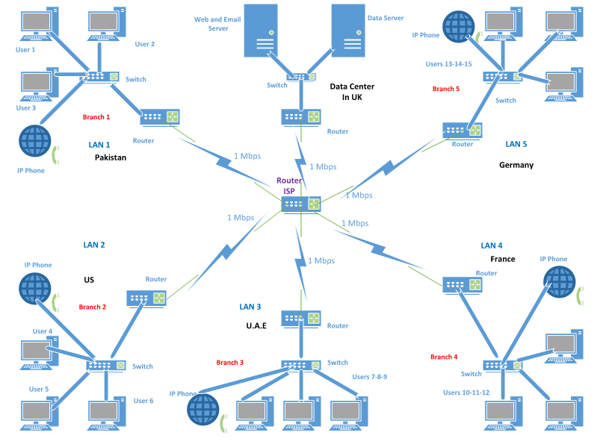
Figure 2.1- Diagram of Network

2.4 Synthesis
The network enables the organization having branches in different countries to communication with each other through a secure channel. There is no need to exchange organization data by relying on internet servers.
The thing which should be kept in mind is that the network should help the organization to also reduce its expenses.
(Adrian Farrel, 2009) It is necessary to have a good infrastructure to access and manage these devices from a central location to reduce the cost of the network management infrastructure
The security of the network should be handled by the management the access control list is used in this project to restrict the employees to certain tasks moreover each user has his password which can be changed. So the security challenges addressed in related literature are been addressed. Whereas the maintenance of the network can be carried out by regularly checking the network and testing it.
The focus is on the security on maintenance of network is important but the performance and benefits of the network should not be compromised. The basic needs for which the network was created should be full filled and the users and the customers should be able to benefit from them.
This network enables the branches to access the information kept in one country through a centralized system. The branches can have their email domain and IP phones to do voice communication as well. The network also helps to put restrictions on the users of it.

Chapter 3
Research Methodology
A research was carried out on different networks which are spread across the countries and how they were created and what technologies they are using. After detailed examination a technique was developed to create this project and to achieve the desired goal.
3.1 Research Methodology
The technologies used now a day’s to create different networks were studied. After the research the network design was created by keeping in view the designs used to create networks across the countries. Different routing protocols were studied and there pros and cons. Then the best routing and networking protocol was implemented in this project.
In order to enable the computers in different branches of the organization to communicate with each other and to access data from the main server in the other country routers will be used. Firstly the routers are been configured with DHCP to give IP’s automatically to the devices. Then the OSPF routing protocol is used to allow the computers in different countries to communicate with each other and to access the information from servers as well. Any information from one PC will be send to another branch PC through a central ISP router and same is the case for getting access to organization’s servers. The access control list is used to restrict the employees to certain tasks.
3.2 Research Instrument
The instrument used for this project is Cisco Packet Tracer which is a simulator for creating networks and checking their behavior. The Cisco Packet Tracer is the well-known tool for creating and analyzing different types of networks and it gives accurate information related to any technical information and helps to implement it in real life easily.
3.3 Data Collection Procedure
First of all the problem was identified that what needs to be done to make the branches of same organization communicate privately over internet and make it possible for them to access information no matter in which country there branch is. Then the requirements was gathered that how exactly the network should be established and which can be implemented in real life. Other networks were observed that which technologies they are using to make communication possible between different branches. Then a network design was created to know how exactly the network would look like and it was checked whether the requirements of the organization are been fulfilled to make use of this network.
Chapter 4
Presentation, Analysis and Interpretation of Data
This chapter will include the design of the network that how the network was designed. This chapter will also include all the techniques used and the configurations which were carried out in order to achieve the desired goals.
4.1 Functional Requirements
Following are the functional requirements of this project:
- User should be able to connect to the default gateway of its branch.
- User should also be able to connect to the central ISP router.
- User should also be able to communicate with other branches worldwide.
- User should also be able to make use of IP Phones for voice communication.
- User should be able to access the Web and E-mail server as well as the FTP server for transferring of data.
- Each user should have its own E-Mail address with the company domain.
- User should have certain restrictions on tasks which aren’t part of his job.
4.2 Non-Functional Requirements
Following are the functional requirements of this project:
- The network should be able to transfer information between different branches smoothly.
- The network should be user friendly which means users should not face any difficulty in performing any specific task.
- The bandwidth of the network should be enough to accommodate the any amount of traffic generated by the network.
- The speed of the network should be enough that data should be transferred without any delays or loss of packets.
4.3 System Specifications
Following are the system specifications of this network:
- First all the Nodes should be working properly and active.
- The connections between the nodes and the routers should be working and correctly plugged at the proper interfaces.
- The routers should be configured with DHCP and provide the IP’s automatically to the nodes.
- The Access Control List should work properly.
- The IP phones should be configured properly and have their own directory number.
4.4 Project Deliverables
Following are the project deliverables:
- Project Proposal.
- System requirements and specifications.
- Project Design
- Project Testing
- Project Implementation.
4.5 Software Process Model
The model starts with the initial phase of requirement gathering. First of all the requirements are gathered and analyzed that what requirements can actually be full filled. After this process next comes the stage of project design. Till the design phase everything is in the form of documentation. After this phase comes the implementation phase where the actual implementation of the project takes place. The final phase is known as the testing phase where the project is tested for any errors and they are removed.

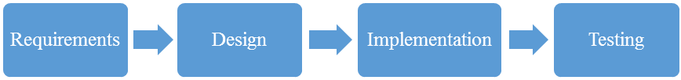
Figure 4.1- Software Process Model

4.6 Hardware Requirements
Following are the hardware requirements of the network:

Table 4.1- Hardware Requirements
Device | Type
Routers | Series 2811
Switches | Series 2950
Nodes | Computers etc.
Cables | Fast Ethernet and Serial

4.7 Software Requirements
Following are the software requirements:
- Cisco Packet Tracer 6.0
4.8 System Requirements
Following are the system requirements for the network:
- An Operating System such as Microsoft Windows.
- A web browser such as Internet Explorer.
- Firmware for IP Phones.
The Internet requirement for transferring of data and communication is Maximum 1 Mbps.

4.9 Network Design
There are five branches of the company in five different countries. Whereas the servers are kept in another country. Now each branch has 3 nodes or PC’s which can be increased as required. Each branch also has an IP Phone to have a voice communication with another branch. The routers on each branch have been configured with DHCP so there is no need to give the IP’s manually. The OSPF was used as a routing protocol. Its purpose is to distribute IP routing information throughout a single Autonomous System in a network There are two servers kept in U.K one is for Web, E-Mail and DNS whereas another is FTP server for file transfer. There is an access control list deployed on the server end to restrict the employee nodes to certain tasks only as required by the organization. There is an ISP router for the internet connection of all the branches and data is transferred between the branches trough this router. Hence the design of the network is shown below:
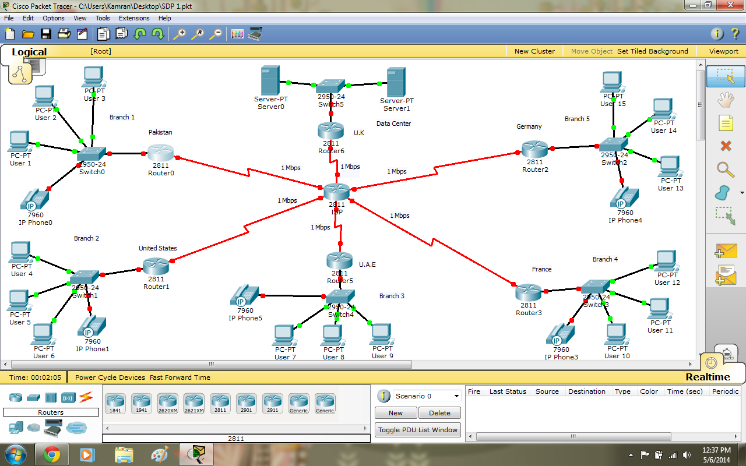
Figure 4.2- Network Design
4.10 Interpretation of Data
The network is developed using the cisco packet tracer. The network is not complicated it can be understand easily and can be tested on the software. The network can be implemented anywhere easily.
The Interpretation of Data is given below:
4.11 Methodology
The user will be able to access the servers through the ISP router. User can access the E-Mail server and Web Server. He can mail to anyone in any branch. User can also access the FTP server for file transfer. User can have voice communication with another user in another branch through IP Phone. Access Control List is also there which can be used by administrators to restrict the users to certain tasks only.
4.12 IP Addressing Scheme
The table on next page shows that what IP addresses are given to different
Networks.
Table 4.2- IP Addressing Scheme
Router | Interface | Description | Network | IP | Subnet
ISP Router
 | Serial0/0/0 | UAE Link | 192.168.10.8 | 192.168.10.10 | 30

Table 4.2- IP Addressing Scheme

Router | Interface | Description | Network | IP | Subnet
 | Serial0/0/1 | France Link | 192.168.10.12 | 192.168.10.14 | 30
 | Serial0/2/0 | UK Link | 192.168.10.20 | 192.168.10.22 | 30
 | Serial0/2/1 | Pakistan Link | 192.168.10.0 | 192.168.10.2 | 30
 | Serial0/3/0 | US Link | 192.168.10.4 | 192.168.10.6 | 30
 | Serial0/3/1 | Germany Link | 192.168.10.16 | 192.168.10.18 | 30
Pakistan Router
 | Serial0/2/0 | ISP Link | 192.168.10.0 | 192.168.10.1 | 30
 | FE 0/0 |  | 192.168.1.0 | 192.168.1.1 | 30
US Router
 | Serial0/2/0 | ISP Link | 192.168.10.4 | 192.168.10.5 | 30
 | FE 0/0 |  | 192.168.2.0 | 192.168.2.1 | 30
UAE Router
 | Serial0/2/0 | ISP Link | 192.168.10.8 | 192.168.10.9 | 30

Table 4.2- IP Addressing Scheme
Router | Interface | Description | Network | IP | Subnet
 | FE 0/0 |  | 192.168.3.0 | 192.168.3.1 | 30
France Router
 | Serial0/2/0 | ISP Link | 192.168.10.12 | 192.168.10.13 | 30
 | FE 0/0 |  | 192.168.4.0 | 192.168.4.1 | 30
Germany Router
 | Serial0/2/0 | ISP Link | 192.168.10.16 | 192.168.10.17 | 30
 | FE 0/0 |  | 192.168.6.0 | 192.168.6.1 | 30
UK Router
 | Serial0/2/1 | ISP Link | 192.168.10.20 | 192.168.10.21 | 30
 | FE 0/0 |  | 192.168.6.0 | 192.168.6.1 | 30
4.13 Network Configuration
The Routers configuration in each branch is carried out by commands shown below the router is also configured with DHCP to give IP’s automatically:

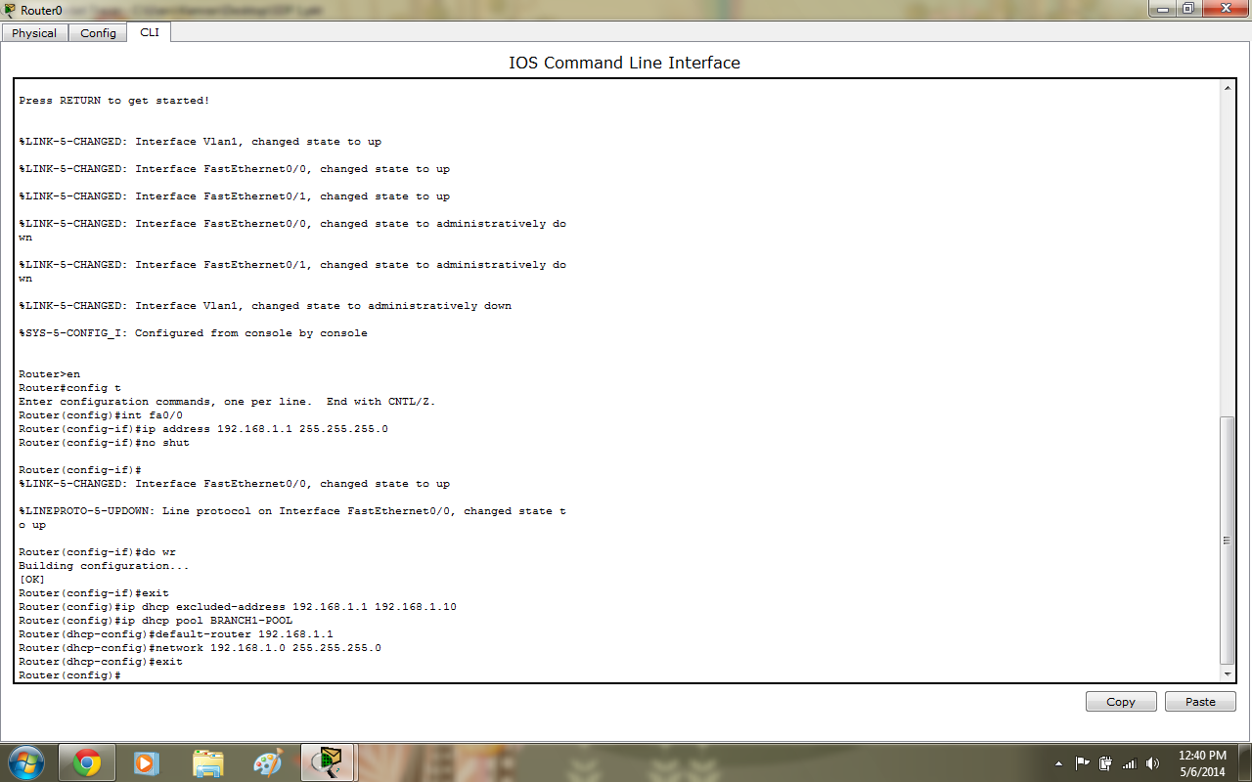
Figure 4.3- Router configured along with DHCP
The User of the company gets the IP address automatically as shown below:
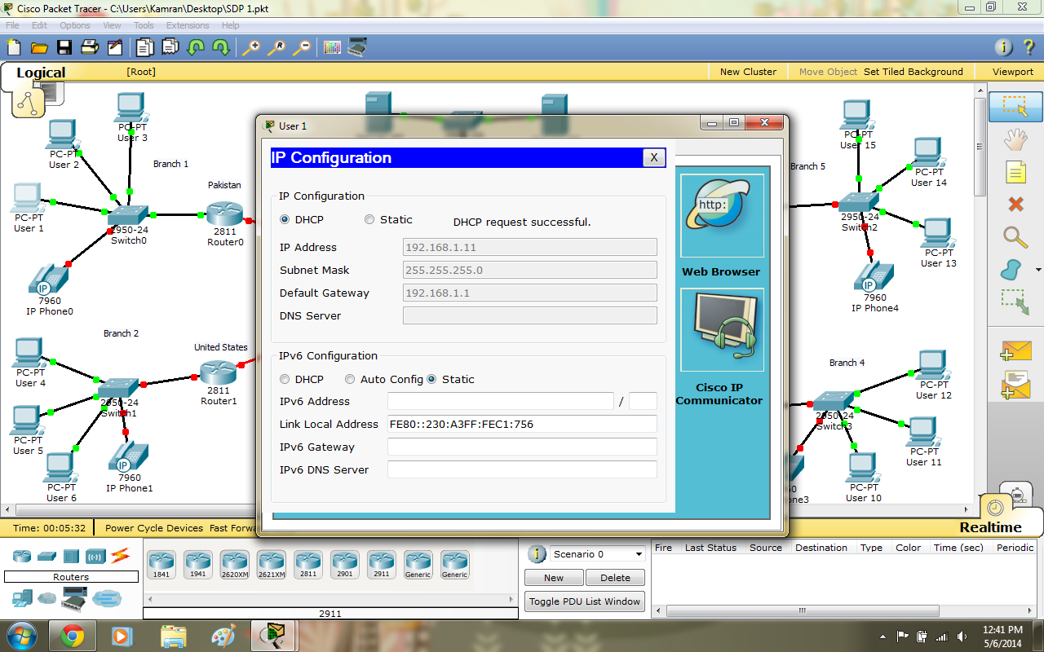
Figure 4.4- User getting IP automatically
To check the connection is working a ping is send from user to router and the packets are send successfully as shown:

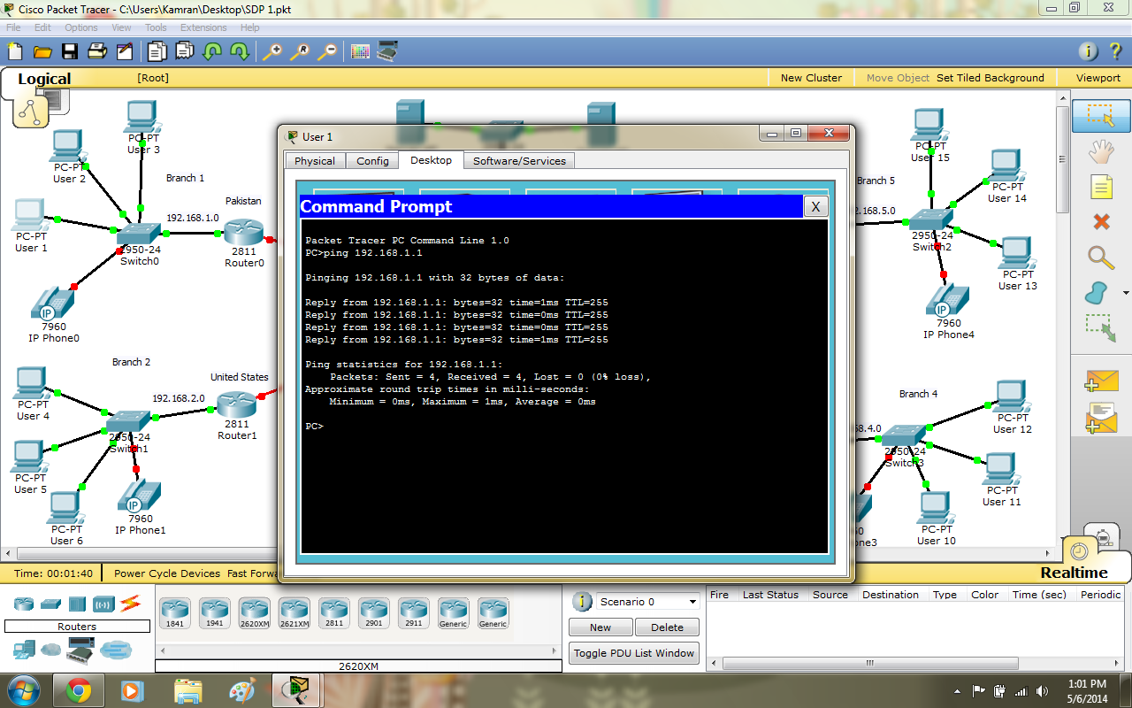
Figure 4.5- Sending Ping to router

The servers are allotted the IP’s manually as it is recommended shown below: 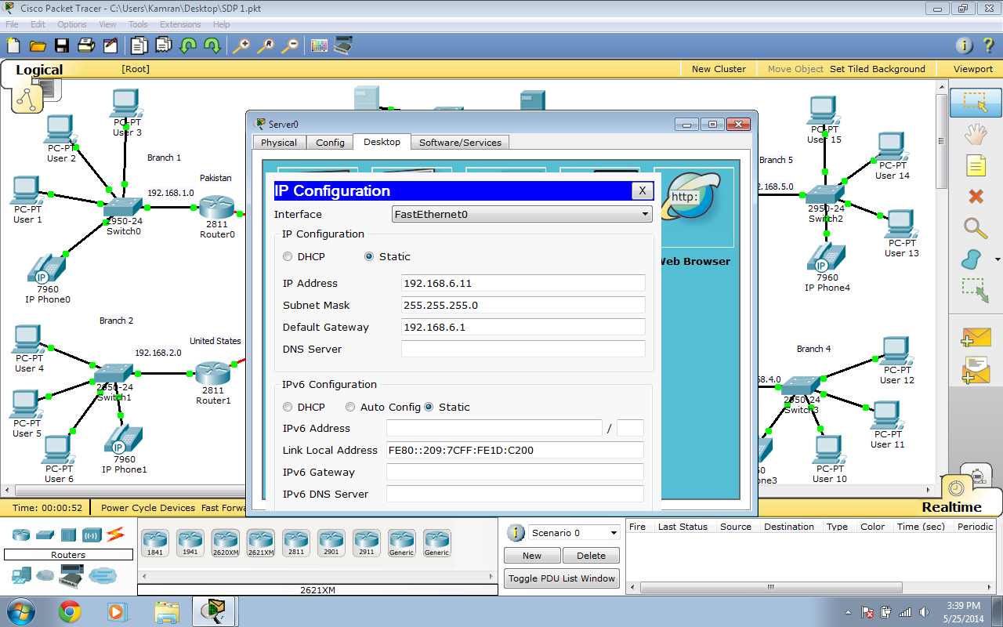 Figure 4.6- Server is getting manual IP
Similar is the case for FTP Server:

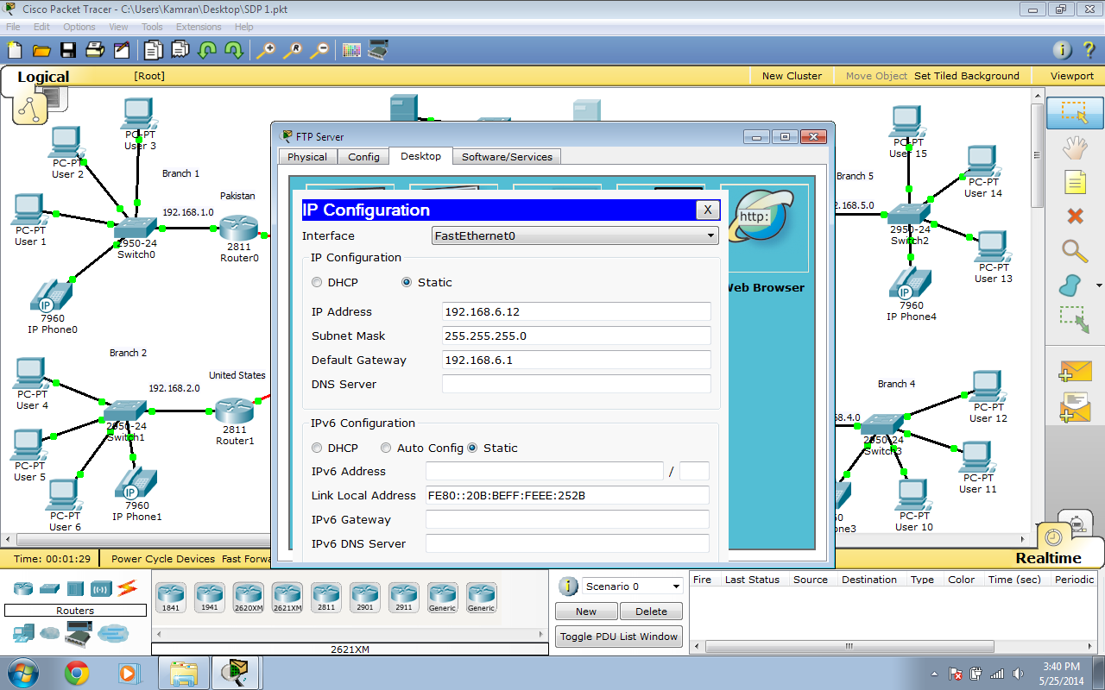
Figure 4.7- FTP getting manual IP
Now the routers of each branch are connected to the ISP router by following configuration:
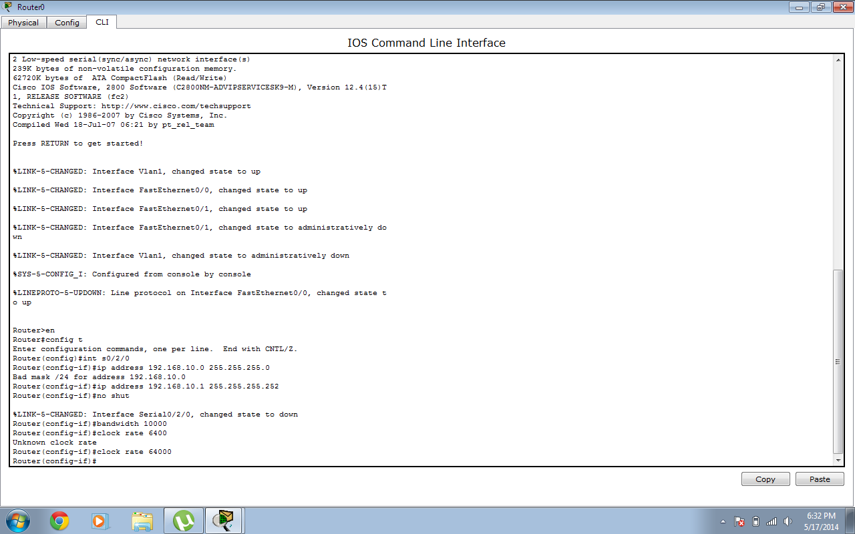
Figure 4.8- Router connecting to ISP

Now following configuration is carried out to on ISP router and the connection between one branch and router is established as shown:
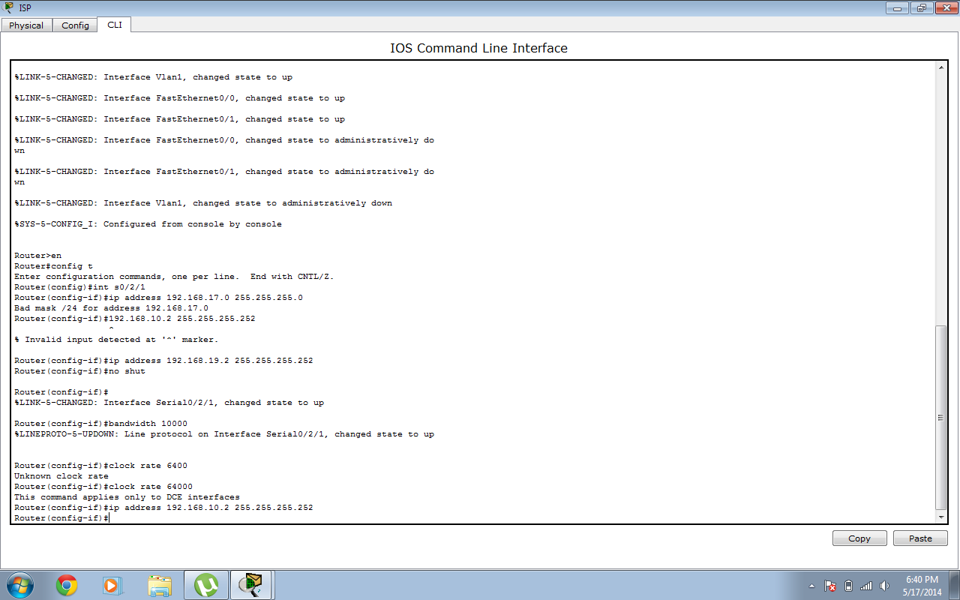
Figure 4.9- Branch router and ISP gets connected

Now in order to establish connection between two routers OSPF is used as shown:
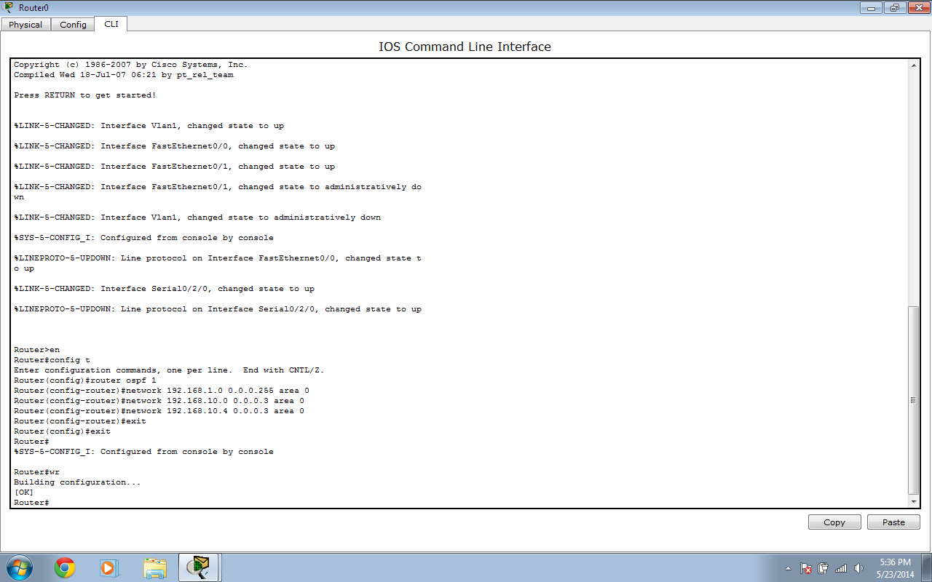
Figure 4.10- Two routers configuration
Now we give configuration to router of another branch in order to connect to the first one as shown below:
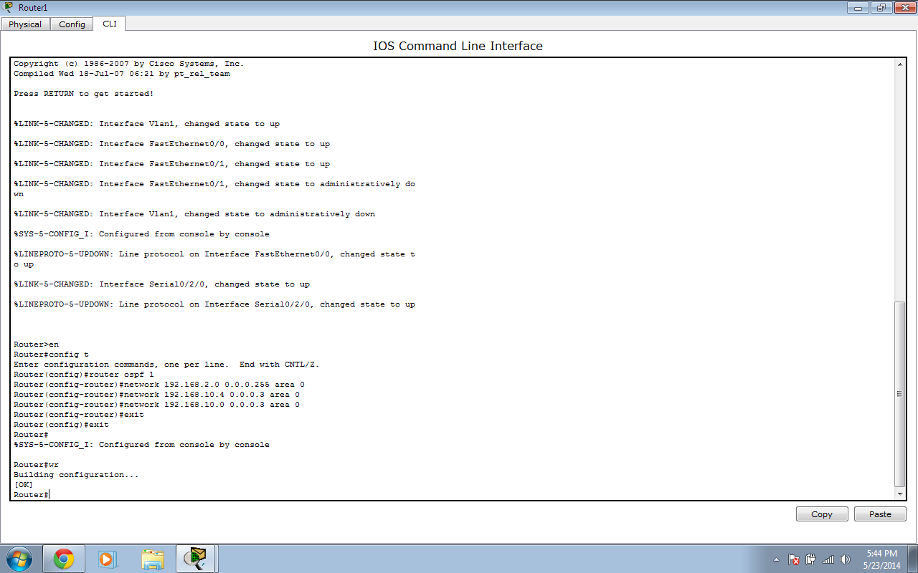
Figure 4.11- Routers been configured
Now the configuration is given to the ISP router is order to complete the process and allow the two branches to connect with each other likewise all branches are connected:
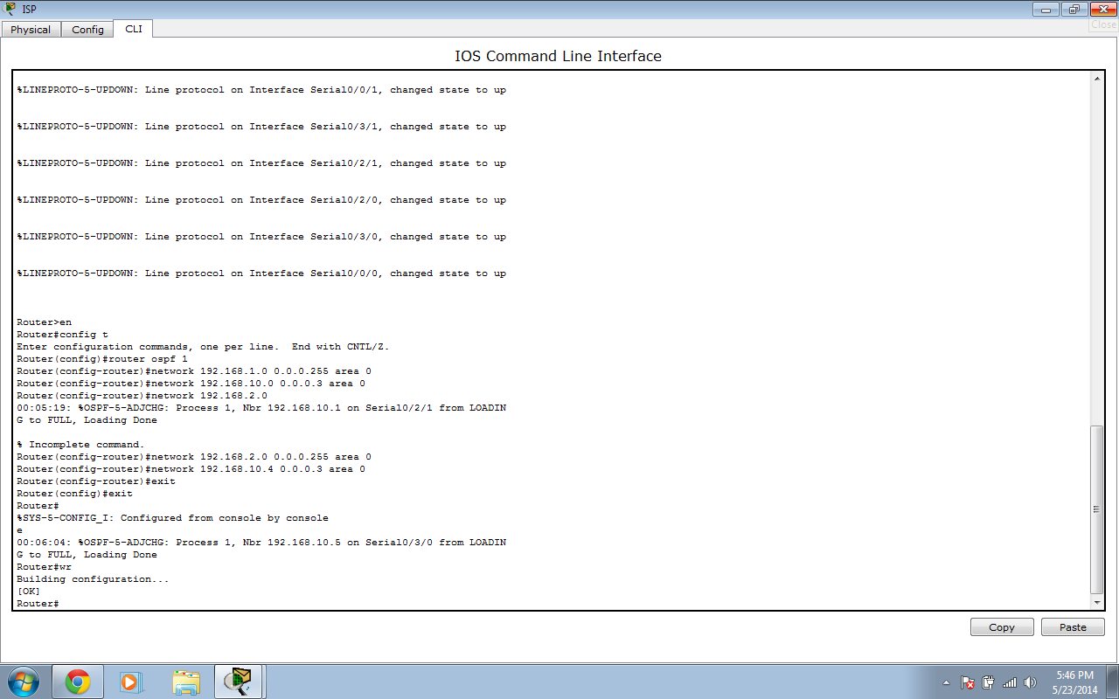
Figure 4.12- ISP configured finally
Now we need to configure the E-Mail server so we create domain name, user name and password as shown below:

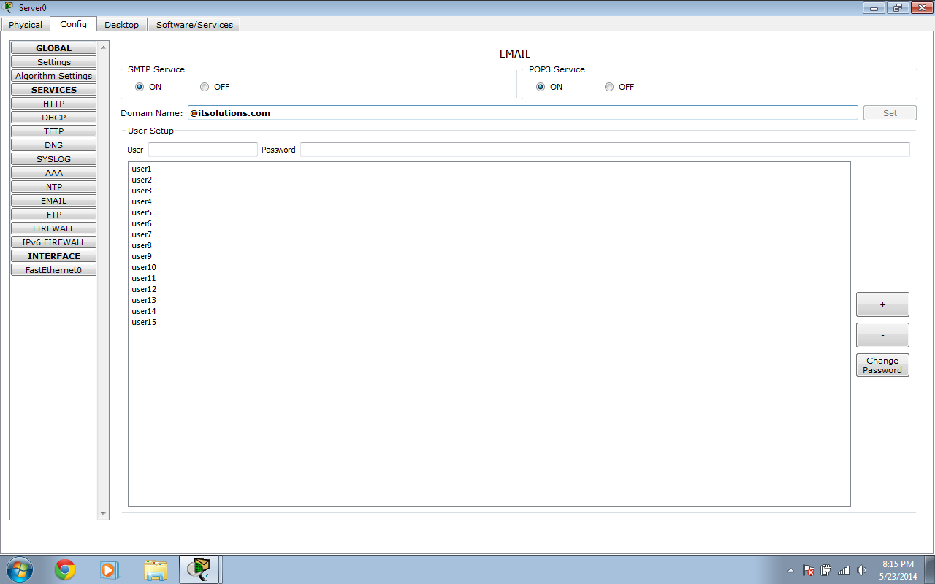
Figure 4.13- E-Mail Configuration
Now each users E-Mail account is created to allow E-Mail communication as shown:

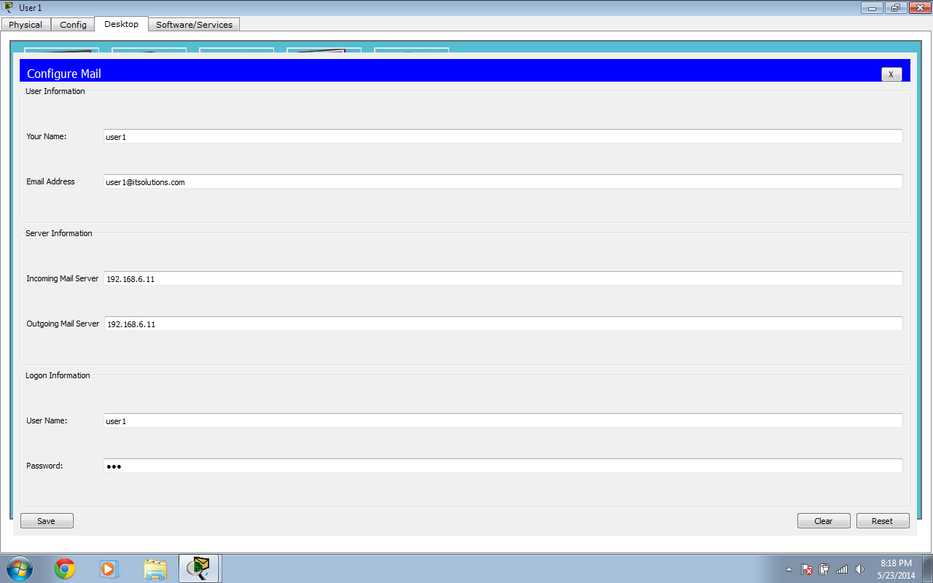
Figure 4.14- E-Mail account sign up
Now in order to check that email is working a user of one branch sends an email to another user of same branch:
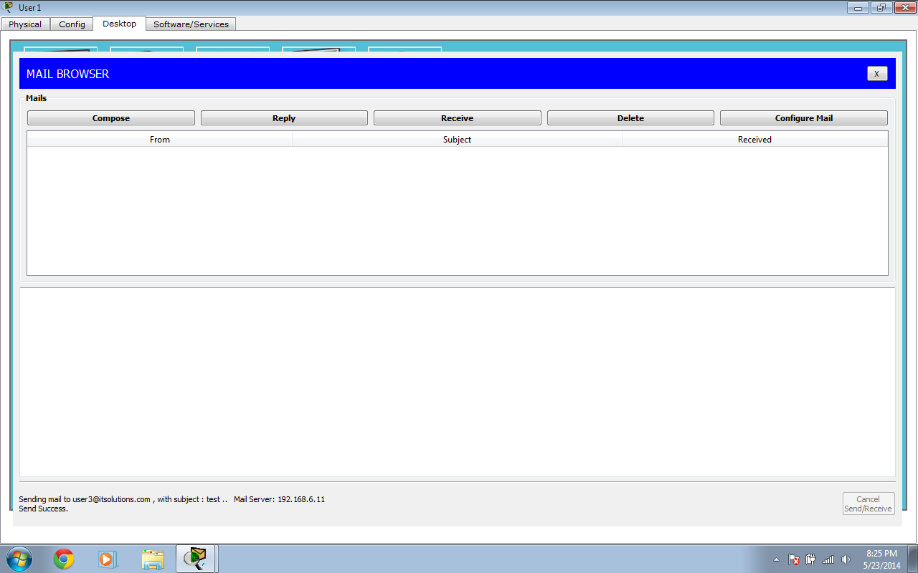
Figure 4.15- E-mail Send
Now email is shown as received:
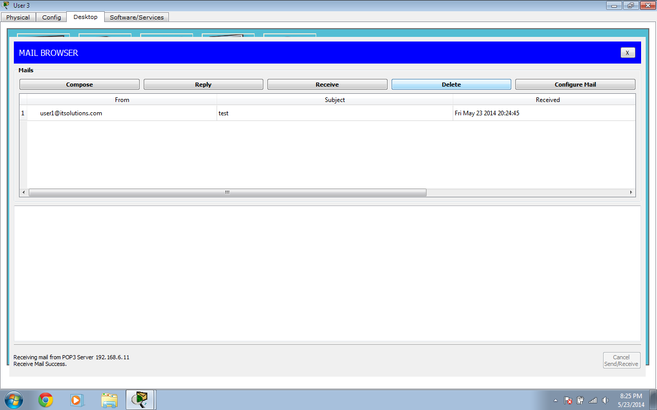
Figure 4.16- E-Mail Received

The user of one branch can also send and receive email from user of another branch as shown below:
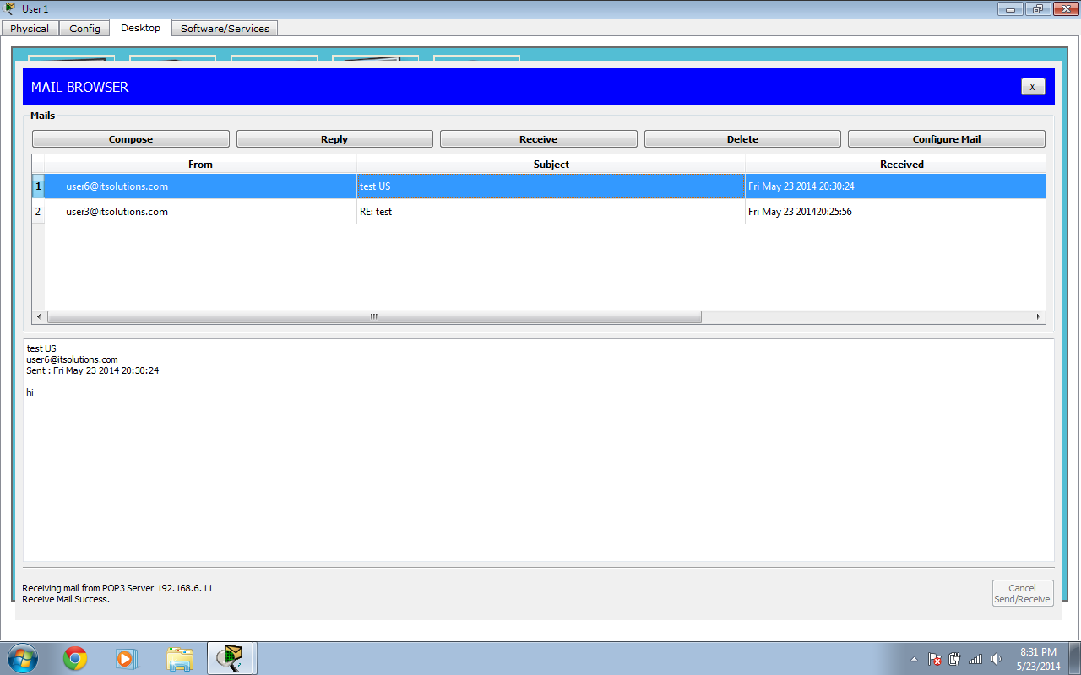
Figure 4.17- E-Mail Received from another branch
Now the FTP server is configured to with username and password and permissions which should be given to users on each branch as shown below:
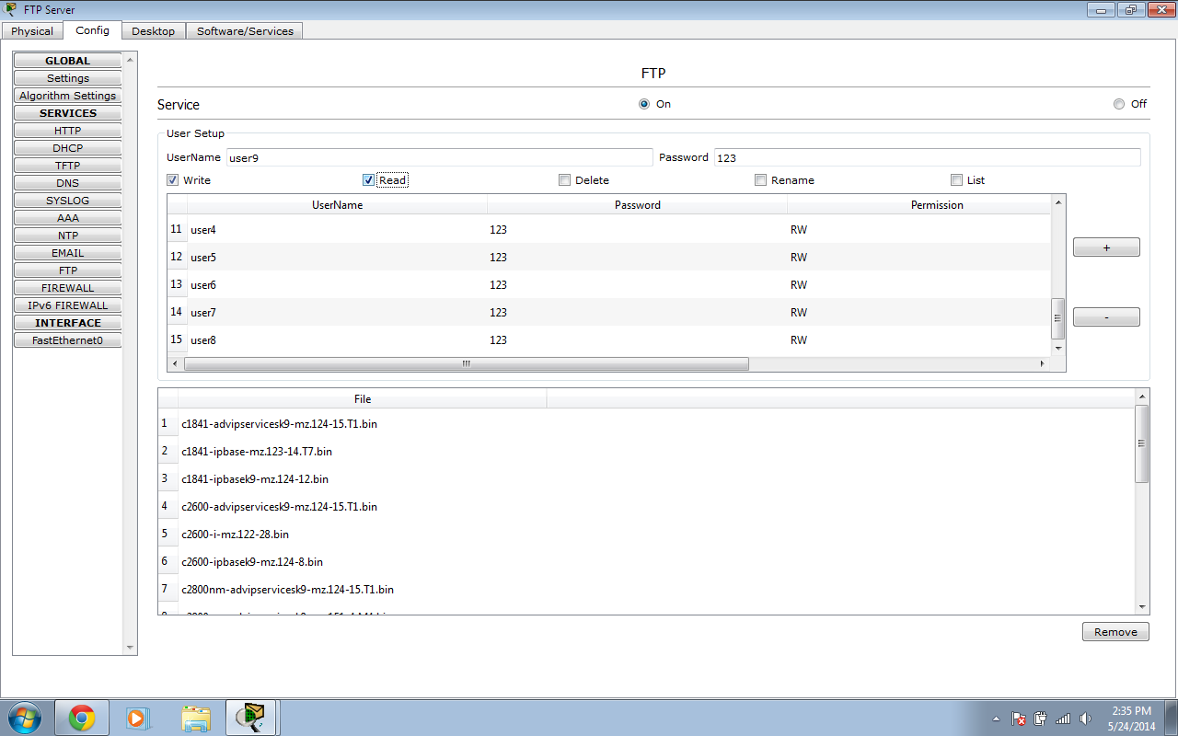
Figure 4.18- FTP Server configuration
Now a user of one branch is accessing the FTP server and has to enter username and password as shown below:

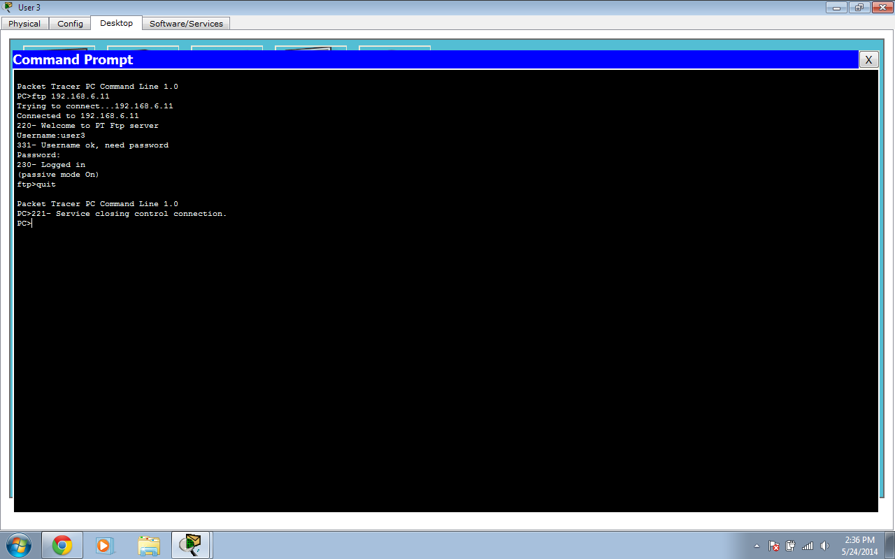
Figure 4.19- User accessing FTP Server
Now a DNS server is configured for the website as shown:
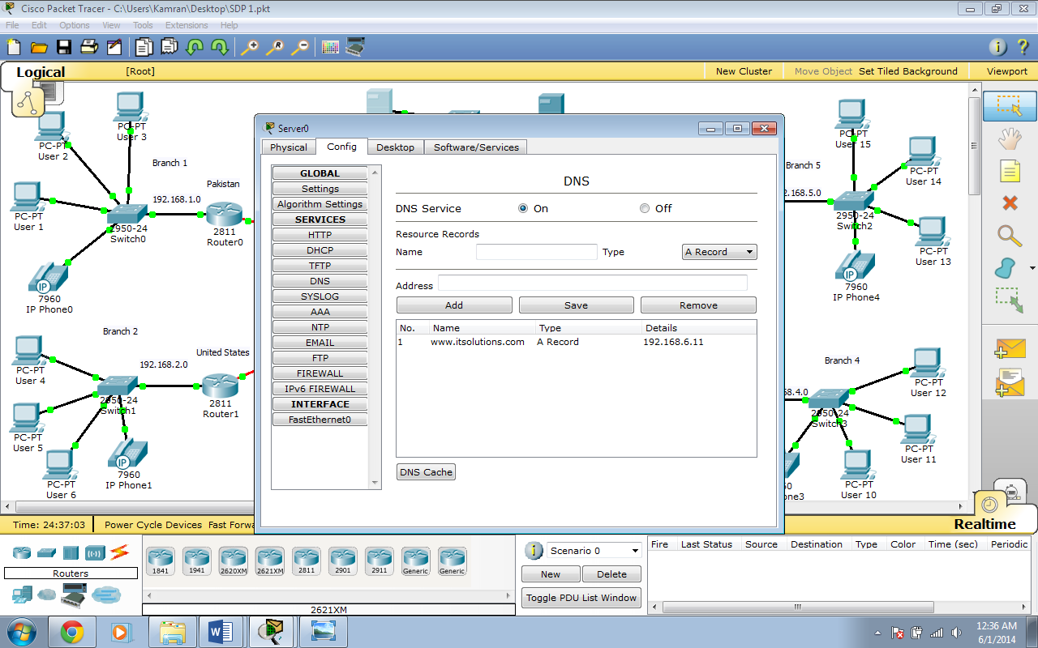
Figure 4.20- DNS Server configuration
Now the router of each network is given the DNS IP to allow the users to access the website as shown below:
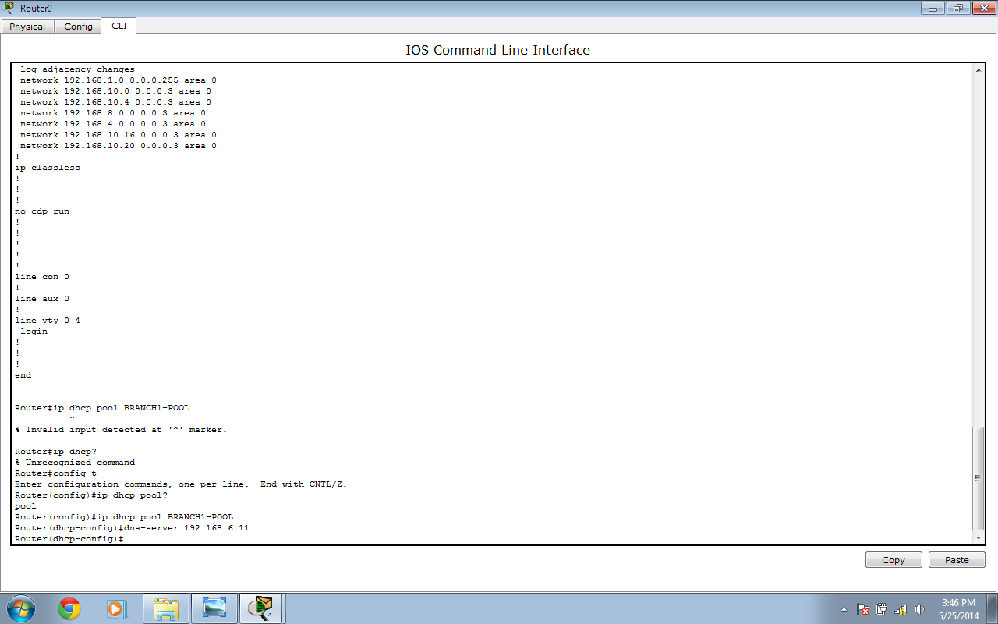
Figure 4.21- Router configured with DNS
Now the user of any branch can access the website as shown below:
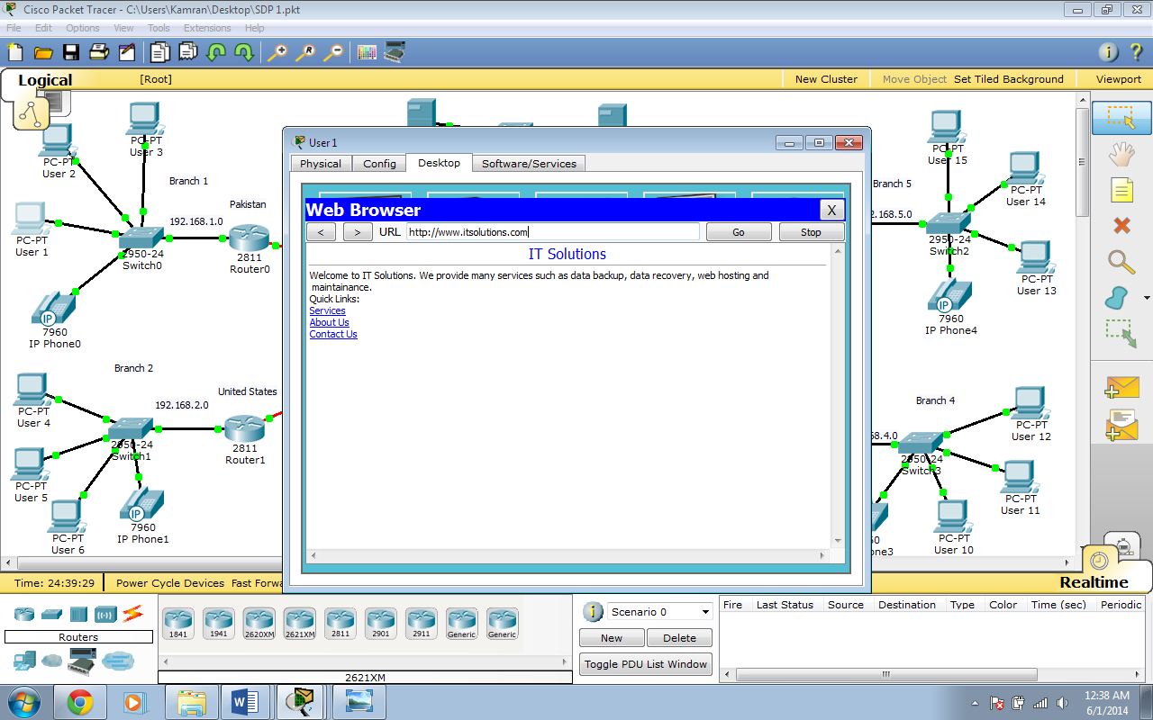
Figure 4.22- User accessing the Website
Now Access Control List needs to be configured on each router which is shown below:

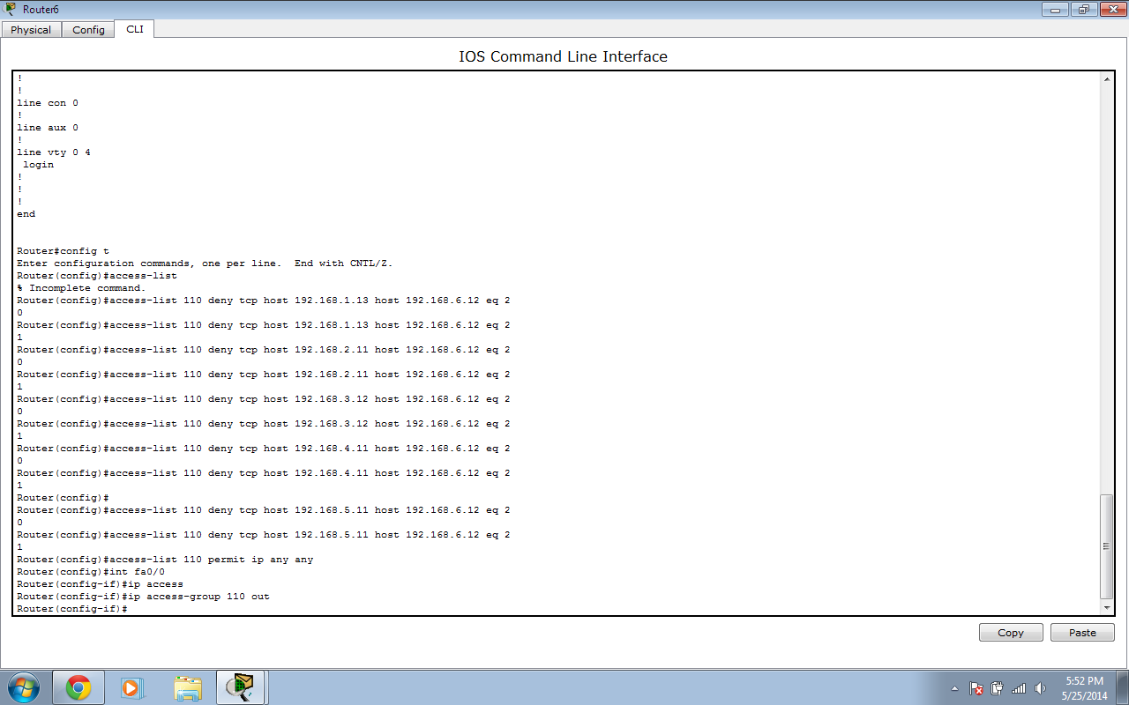
Figure 4.23- Router configured with ACL
Now the User is shown which is denied access to the FTP server:
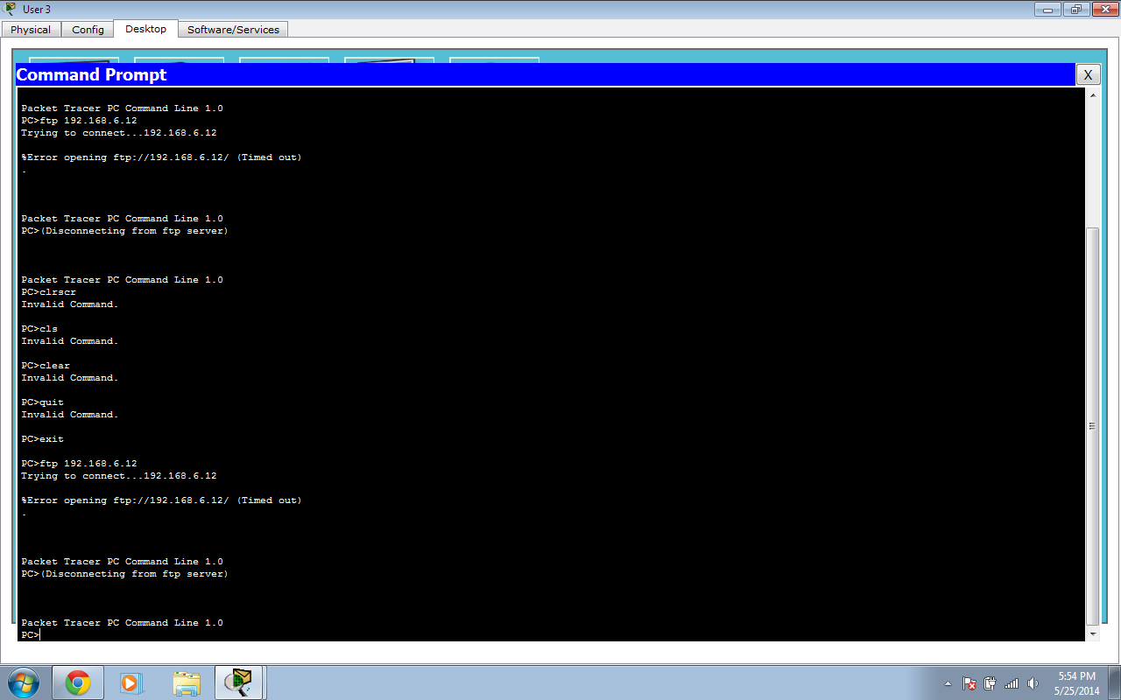
Figure 4.24- User denied to access FTP Server
Whereas the users who are allowed access to FTP server can access it as shown below:
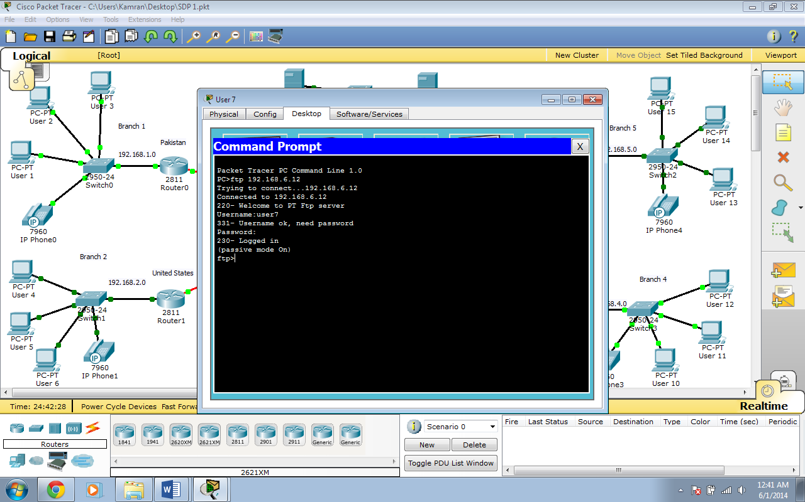
Figure 4.25- User getting access to FTP Server

Now we need to configure the IP Phones in order to enable different branches to communicate with each other as shown below:
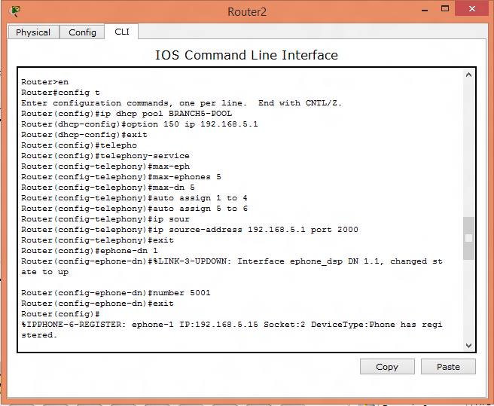
Figure 4.26- IP Phone Configuration

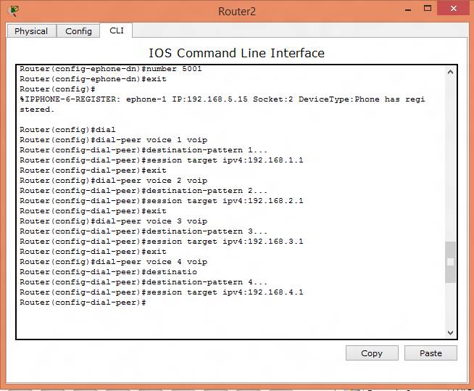
Figure 4.27- IP Phone Configuration
Following configuration is done on the switch as well:
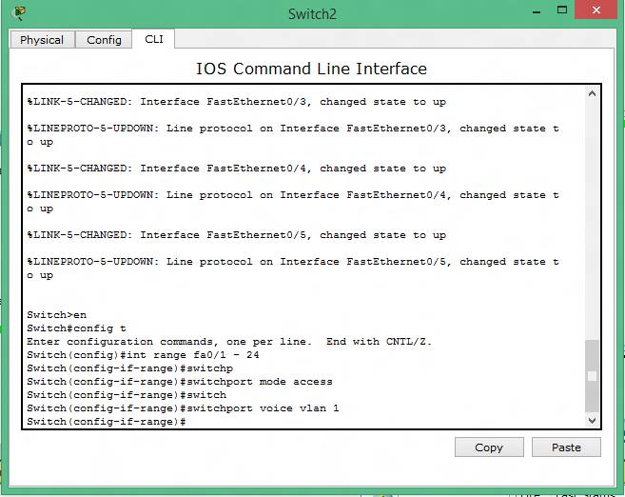
Figure 4.28- IP Phone Configuration in switch
Now the IP Phones are connected and voice communication can be established as shown below:
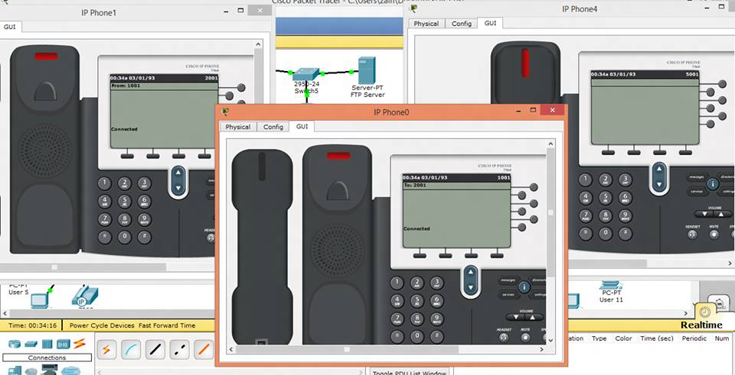
Figure 4.29- IP Phone Connected
Now the network is completely operational as shown below:
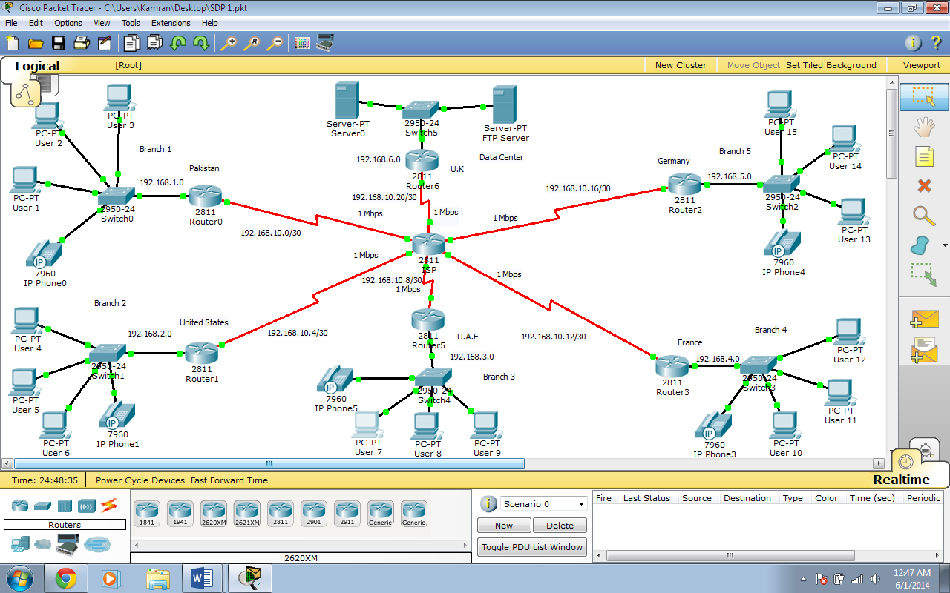
Figure 4.30- Network Completed

Chapter 5
Summary of Findings, Conclusions and Recommendations
5.1 Summary of Findings
The basic objective of the project was to create a network which can enables the branches of same organization in different countries to communicate with each other and be able to send information. The users of different branches can communicate and transfer date between each other. They can also email to other users as well. Moreover the voice communication can also be established by them by using IP Phones on this network. There are restrictions on certain users as well to limit them to certain tasks only. The network was created by using the Cisco Packet Tracer.
5.2 Conclusions
Now-a-days technology is getting advanced day by day. Gone are the days when there were many hurdles to transfer information or to communicate with each other over far distances.
The networks are playing important role in our daily life. It is because of them we can transfer information from one place to another keep up to date and also to communicate with each other. New standard are coming and are changing our lives.
The networks has solved a number of problems for us we can connect a number of devices over a single network and can monitor them easily. The data has also gotten centralized so everyone can access the information from anywhere so everyone is connected.
The network created on the project has solved the problem for the organization. Now all the branches are connected and they can access the information from anywhere as the data is centralized. They can communicate with each other using voice or email can access and share the files. So the network has played an important role to increase the performance of the organization. It can be implemented anywhere and will be beneficial.
5.3 Recommendations
The network can be further enhanced by adding more features such as by using the Virtual Private Network. The firewall can be used to block the ports which are not been used at any given time. And a backup communication channel can also be created which can be used when the main communication channel is down.
5.4 Future Research
The project can be studied to design a network where different branches in any location can be linked together and centralized data servers can be used for the transfer of information. Apart from the features which are already places in this project more can be added which will make the network more efficient. The Virtual Private Network can be used in this project which help the data to be accessed remotely. The firewall can be used to block the ports which are not been used or are inactive. A secondary link can also be created as a backup link.

References
- Adrian Farrel, 2009 “Network Management know it all”
Source: http://s1.downloadmienphi.net/file/downloadfile7/172/1378210.pdf
- John E. Canavan, 2001 “Fundamentals of Network Security”
Source: http://f3.tiera.ru/other/DVD-005/Canavan_J.E._Fundamentals_of_network_security_(2001)(en)(218s).pdf

Kamran Khalid
Contact No: 055-7692691
E-Mail: kamran.khd@outlook.com
Personal Profile:-
I am a final year IT Student having a good knowledge in the field of technology. I am a hard working individual who have good communication and presentation skills. I am able to work under pressure. I wish to find a job which can provide me an opportunity to gain experience and help me to apply my knowledge into practical life.
Teamwork Skills:-
- In my 3 years as a student of IT I have worked in various groups to create presentations and to present them to the audience.
- I have also worked together with others to build numerous projects related to IT.
- I have also worked in teams to find solution of different problems.
Communication Skills:-
- I have given many presentations in university.
- I have delivered few speeches as well.
- I was required to write Reports on different projects.
Problem Solving Skills:-
- I was given different types of mathematical problems which I was asked to solve.
- I was also provided with Physics Numerical questions to provide the solution for them.
- I have solved various problems related to Statistics and Probability.
Leadership Skills:-
- I do possess a few leadership skills.
- I am able to give few tips to others to help them come out of difficult situations.
- I am able to suggest a solution to problems which may arise.
IT Skills:-
- I have knowledge of Internet and Microsoft Office.
- I have a very good knowledge of Windows Operating System.
- I know PC Troubleshooting and Assembling.
- I have learned programming language C++.

Education:-
2009 - To Date Bachelor of Science in Information Technology (BSIT)
SZABIST University, Dubai, U.A.E
2007 - 2009 HSSC (Computer Science) Federal Board, Pakistan
Sheikh Khalifa Bin Zayed Arab Pakistan School, Abu Dhabi, U.A.E
2005 – 2007 Matriculation (Computer Science) Federal Board, Pakistan
Sheikh Khalifa Bin Zayed Arab Pakistan School, Abu Dhabi, U.A.E
Achievements:-
- Participated in the 1st Engineering Student Renewable Energy Competition held at UAE University in 2010 and got 5th Position out of 32 Teams.
- Completed Intermediate Level 3 of General English from British Council with 86% in 2009.
Language Proficiency:-
- English: Written/Spoken
- Urdu: Written/Spoken
License Status:-
- Valid U.A.E Driving License.
Interests:-
- I have interests in Networking and learning about latest technology.
Additional Information:-
- I have learnt a bit of Arabic.
- I have gained confidence over the years.
- I have learnt to handle difficult situations with wise decisions.
Personal Details:-
Name: Kamran Khalid
Gender: Male
Date of Birth: 29th May, 1991
Marital Status: Single
Nationality: Pakistani
Religion: Islam
Visa Status: Valid U.A.E Residence Visa

